PRESS RELEASE AND BOOK LAUNCH EVENT

We are glad to invite you at the book launch of the book Drawing and Experiencing Architecture by Marianna Charitonidou that will take place at the Amphitheater of Goethe-Institut in Athens on 24 January 2023 at 6:00 pm.
The following speakers will talk about the book:
- Marianna Charitonidou, Postdoctoral Researcher Athens School of Fine Arts
- Andreas Giacumacatos, Professor Athens School of Fine Arts
- Georgios Xiropaidis, Professor Panteion University of Social and Political Sciences
- Constantinos Moraitis, Professor National Technical University of Athens
- Anastasios Kotsiopoulos, Professor Aristotle University of Thessaloniki
The discussion about the book will be coordinated by the chief editor of the magazine Archetype Manolis Oikonomou.
You can use the following link to download the book launch announcement: https://thinkthroughdesign.files.wordpress.com/2023/01/press-release-and-book-launch-event-.pdf

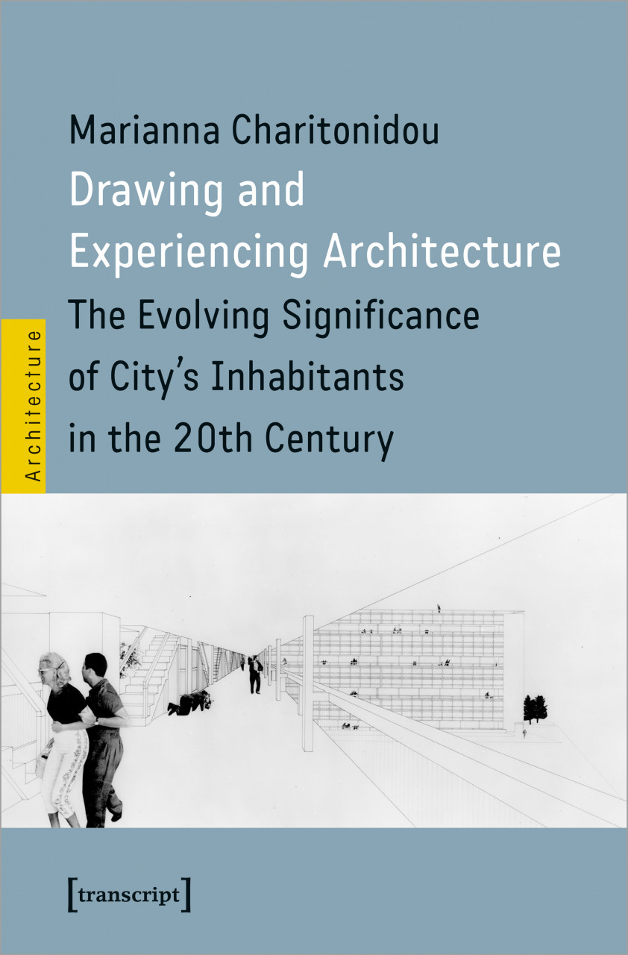

Marianna Charitonidou

Drawing and Experiencing Architecture
The Evolving Significance of City's Inhabitants in the 20th Century]

How were the concepts of the observer and user in architecture and urban planning transformed throughout the 20th and 21st centuries? Marianna Charitonidou explores how the mutations of the means of representation in architecture and urban planning relate to the significance of city's inhabitants. She investigates Le Corbusier and Ludwig Mies van der Rohe's fascination with perspective, Team Ten's interest in the humanisation of architecture and urbanism, Constantinos Doxiadis and Adriano Olivetti's role in reshaping the relationship between politics and urban planning during the postwar years, Giancarlo De Carlo's architecture of participation, Aldo Rossi's design methods, Denise Scott Brown's active socioplactics and Bernard Tschumi's conception praxis.

€ 45,00
Publication: 12/2022
350 pages
95 black and white images
15 color images
ISBN 978-3-8394-6488-5
doi: https://doi.org/10.1515/9783839464885

For info: Marianna Charitonidou
m.charitonidou@icloud.com
https://charitonidou.com/
Amphitheater Goethe-Institut Athen
24 January 2023
6:00 pm
14-16 Omirou 10672 Athens Greece

https://www.transcript-publishing.com/978-3-8376-6488-1/drawing-and-experiencing-architecture/?c=410000000
Online access to the book: https://www.degruyter.com/document/doi/10.1515/9783839464885/html
To order the book: https://www.transcript-verlag.de/978-3-8376-6488-1
http://cup.columbia.edu/book/drawing-and-experiencing-architecture/9783837664881

transcript - Roswitha Gost & Dr. Karin Werner GbR | Hermannstraße 26 | 33602 Bielefeld | Deutschland | www.transcript-verlag.de | Tel.: +49 521 393 797-0

