Announcement

7 FINALISTS FOR THE 2022

EUROPEAN UNION PRIZE FOR CONTEMPORARY

ARCHITECTURE – MIES VAN DER ROHE AWARD

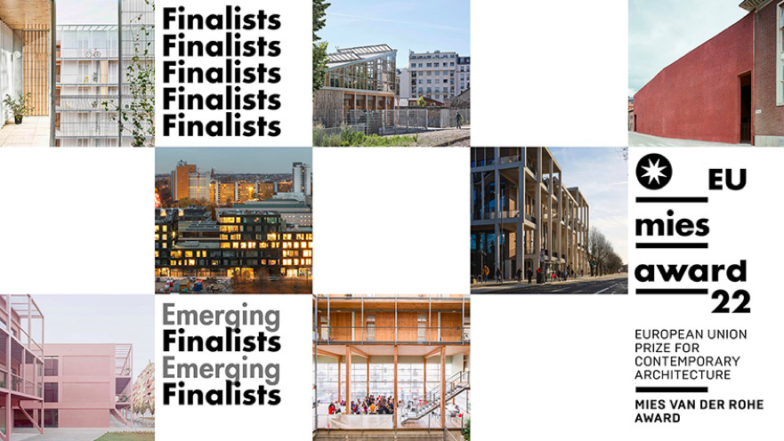

The **European Commission** and the **Fundació Mies van der Rohe** have revealed the **seven finalists** that will compete for the 2022 European Union Prize for Contemporary Architecture – Mies van der Rohe Award, **5 in the Architecture category** and **2 in the Emerging Architecture category.**

The Jury considered that the **7 finalist works** encourage and become **models and references for local city policies:**

THE FIVE ARCHITECTURE FINALISTS ARE:

**→ 85 Social Housing Units** in Cornellà de Llobregat, SPAIN

Architects: peris+toral.arquitectes

Programme: Collective housing

[eumiesaward.com/work/4963](https://eumiesaward.com/work/4963)

**→ Frizz23** in Berlin, GERMANY

Architects: Deadline (Britta Jürgens + Matthew Griffin)

Programme: Mixed use - Cultural & Social

[eumiesaward.com/work/4302](https://eumiesaward.com/work/4302)

→ **The Railway Farm** in Paris, FRANCE

Architects: Grand Huit and Melanie Drevet Paysagiste

Programme: Social welfare

[eumiesaward.com/work/4434](https://eumiesaward.com/work/4434)

**→ Town House - Kingston University** in London, UNITED KINGDOM

Architects: Grafton Architects

Programme: Education

[eumiesaward.com/work/4892](https://eumiesaward.com/work/4892)

**→ Z33 House for Contemporary Art, Design and Architecture** inHasselt, BELGIUM

Architects: Francesca Torzo

Programme: Culture

[eumiesaward.com/work/4912](https://eumiesaward.com/work/4912)

 THE TWO EMERGING ARCHITECTURE FINALISTS ARE:

**→ Enrico Fermi School** in Turin, ITALY

Architects: BDR bureau

Programme: Education

[eumiesaward.com/work/4329](https://eumiesaward.com/work/4329)

**→** **La Borda - Cooperative Housing** in Barcelona, SPAIN

Architects: Lacol

Programme: Collective housing

[eumiesaward.com/work/4554](https://eumiesaward.com/work/4554)

CALENDAR:

In March, the **Jury will visit** the five works in order to select the Prize Winner. The Prize Winner and the Emerging Architect Winner will be announced at the end of April.

The **Awards Ceremony** will take place on **12 May 2022 at the Mies van der Rohe Pavilion in Barcelona**. Save the date for the lectures, debates, exhibition opening and celebration with the Jury members, Winners, Finalists, Clients and other guests and representatives.

|  |
| --- |
| **More information and PRESS KIT:** **[mies.link/PressKit_Finalists2022](https://mies.link/PressKit_Finalists2022)**  - Press release (EN, ES, DE, FR, IT, NL, CA)  - Images of the works *(In order to publish the images, please indicate the name of the photographer)*  - Graphic material & videos |

We remain at your disposal for any further information you may need,

Best regards,

Jordi

|  |
| --- |
| /var/folders/wz/dzzncn2s10xd539062t53gym0000gn/T/com.microsoft.Outlook/WebArchiveCopyPasteTempFiles/jordi-premi-copia.jpg |
| [award@miesbcn.com](mailto:award@miesbcn.com) Provença 318, pral 2a. Barcelona. T[+34 932 151 011](tel:%20+34%20932%20151%20011) [miesbcn.com](http://www.miesbcn.com) | [eumiesaward.com](http://www.eumiesaward.com)| [shopmies.com](http://www.shopmies.com) [facebook](https://www.facebook.com/FundacioMiesvanderRohe)| [twitter](https://twitter.com/FundacioMies" \o "https://twitter.com/FundacioMies) | [instagram](https://www.instagram.com/fundaciomies/" \o "https://www.instagram.com/fundaciomies/)| [vimeo](https://vimeo.com/fundaciomies" \o "https://vimeo.com/fundaciomies) | [newsletter](http://www.miesbcn.com/news" \o "http://www.miesbcn.com/news) |