**INCEPTION PROJECT**

665220 - H2020 REFLECTIVE-7-2014

**INCEPTION Athens course**

6th – 7th November 2017

**National Technical University of Athens**

**Patission 42, 10682**

**Technical Chamber of Greece**

**Nikis 4, 10563 Athens**

**AGENDA**

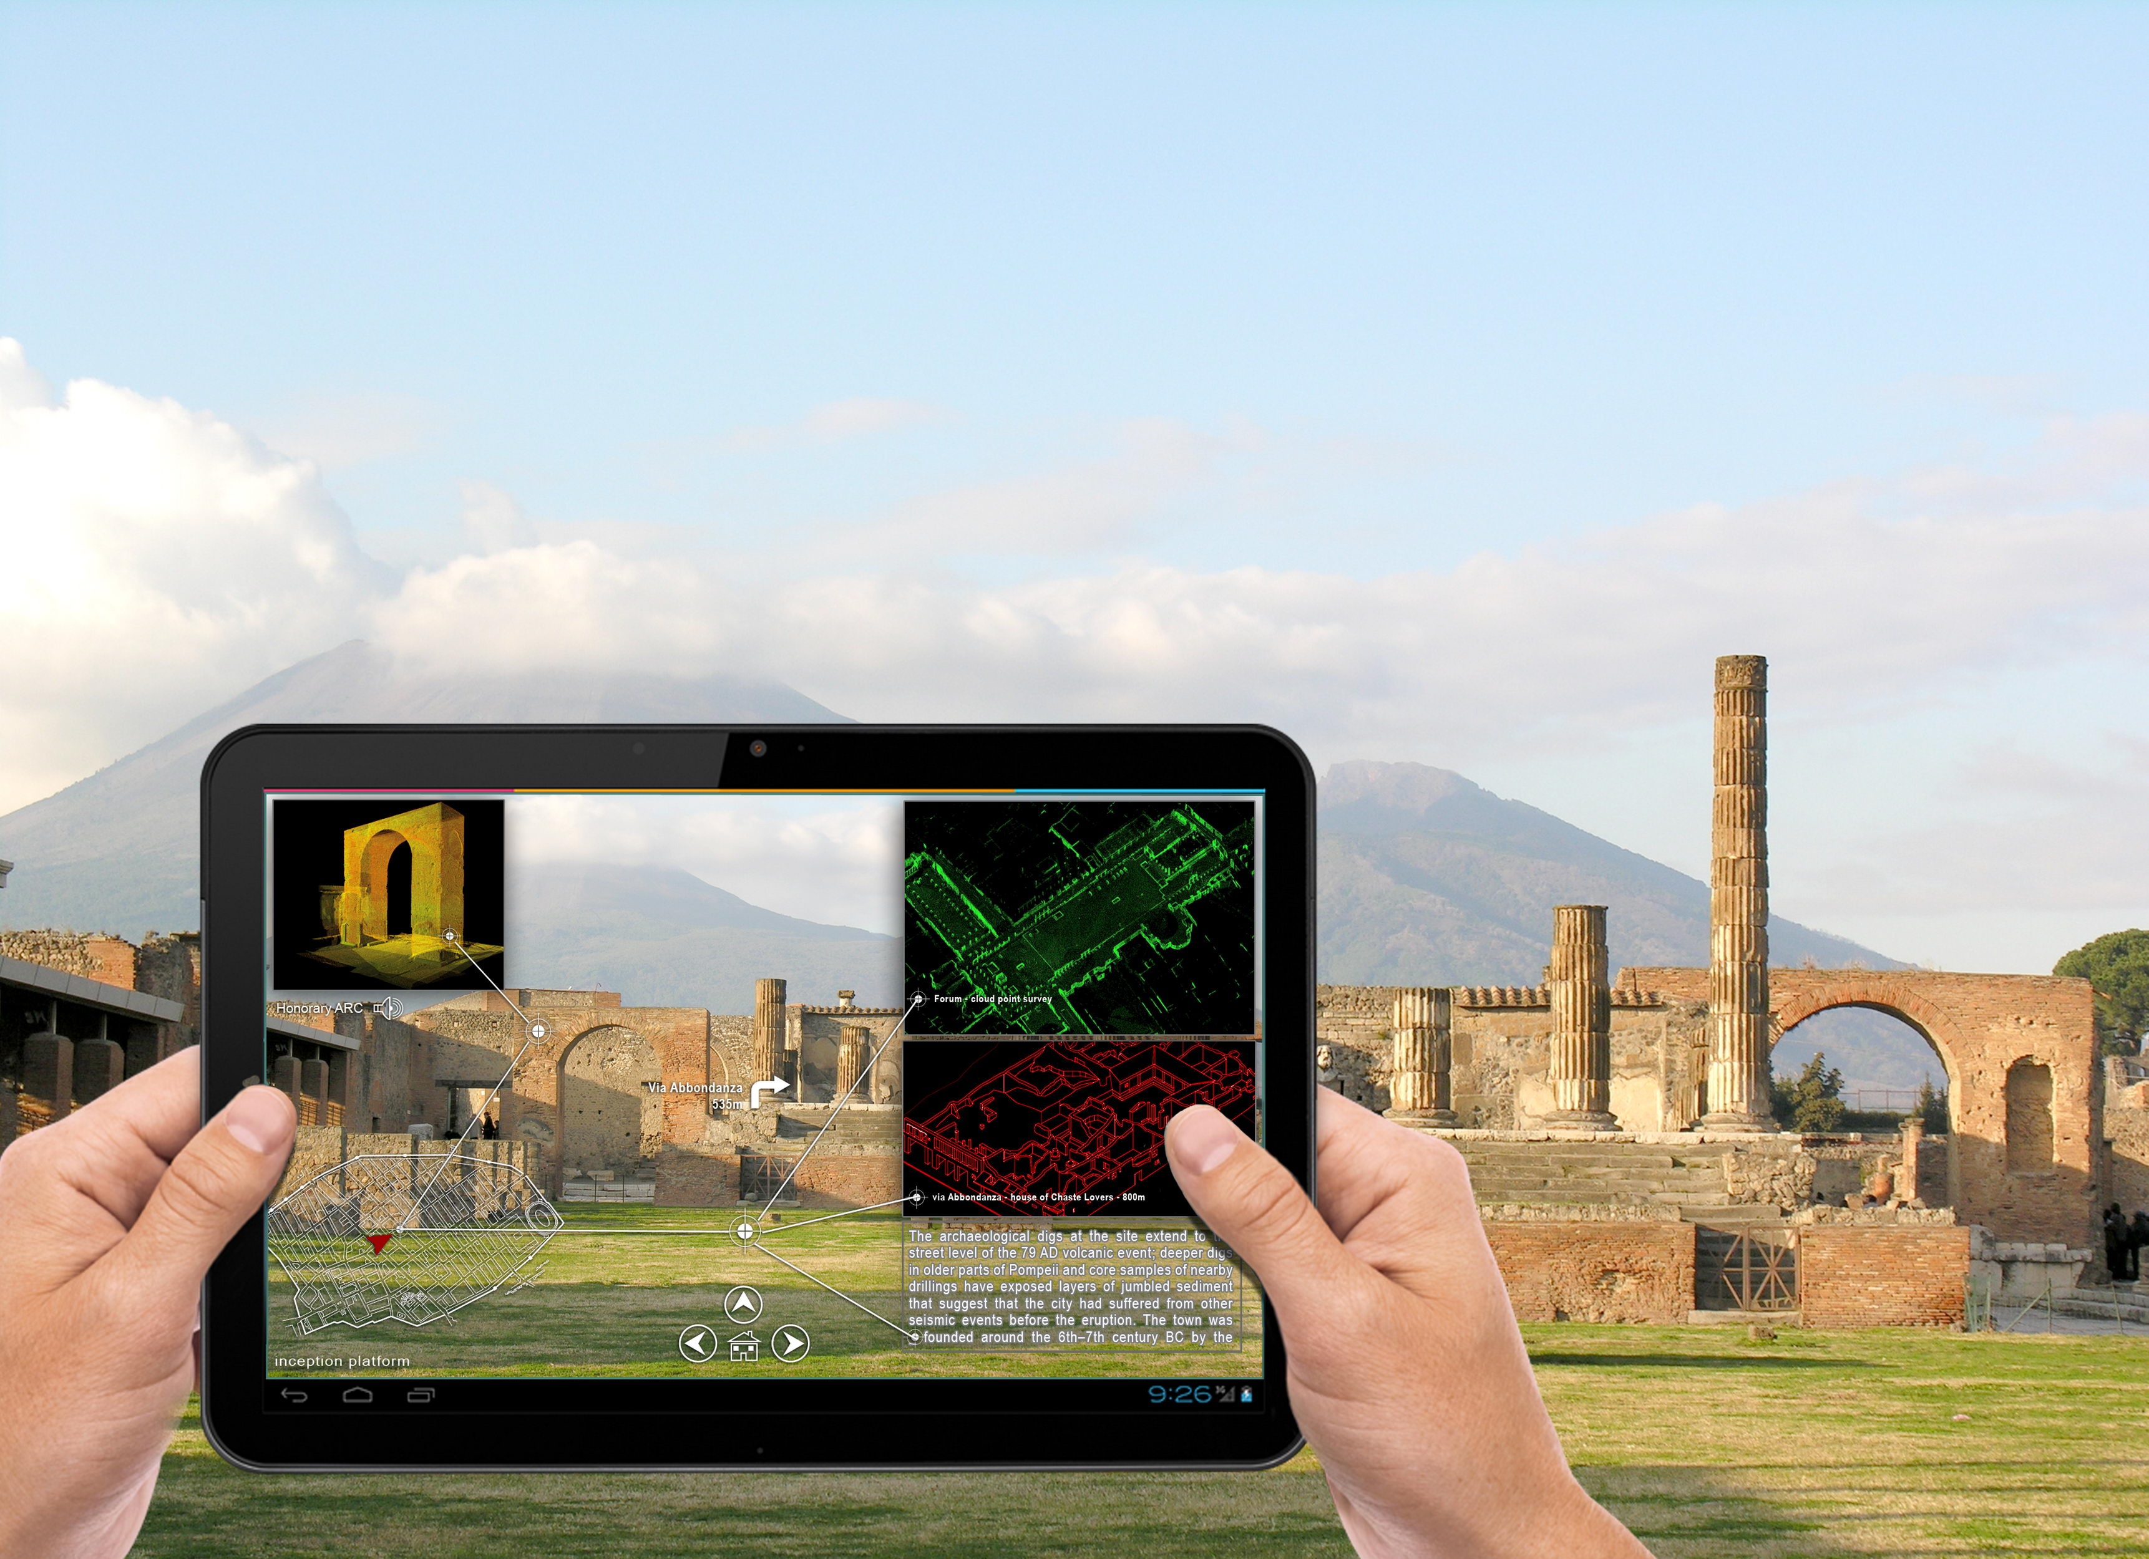**INCEPTION PROJECT**

**INCEPTION Athens course** _ 6th – 7th November 2017

**6th November 9:00 – 18:00 _ INCEPTION Course (Day 1)**

*Athens – National Technical University of Athens (NTUA)*

*Patission Historic complex – Historic Rectorate Hall*

|  |  |  |
| --- | --- | --- |
| Time | Activity | Participants |
| 8:30 – 9:00 | Registration |  |
| **9:00 – 14:30** | **Lectures on INCEPTION H-BIM** |  |
| 9:00 – 9:30 | Opening addresses | NTUA Deputy Rector  D. Isaias (NTUA)  A. Moropoulou (NTUA) |
| 9:30 – 9:50 | Lecture 1: Keynote – General introduction | R. Di Giulio (UNIFE) |
| 9:50 – 10:10 | Lecture 2: On the significances of Cultural Heritage assets | R. Zarnic (UL) |
| 10:10 – 10:30 | Lecture 3: Knowledge management approach | M. Ioannides (CUT) |
| 10:30 – 10:50 | Lecture 4: 3D acquisition and modelling of complex heritage buildings: the INCEPTION Protocol | F. Maietti (UNIFE) |
|  | **Coffee Break** |  |
| 11:20 – 11:40 | Lecture 5: Enhanced field workflow for 3D laser scanning | D. Blersch (Z+F) |
| 11:40 – 12:00 | Lecture 6: Usability of 3D documentation methods for the creation of H-BIM models | C. Ioannidis (NTUA) |
| 12:00 – 12:20 | Lecture 7: Introduction to semantic web standards and their application on INCEPTION | A.E. Ziri (NMR) |
| 12:20 – 12:40 | Lecture 8: INCEPTION H-BIM Ontology | P. Bonsma (RDF) |
| 12:40 – 13:00 | Lecture 9: INCEPTION platform architecture and IT technical solutions | E. Iadanza (CFR) |
|  | **Lunch Break** |  |
| **14:00 – 15:30** | **Round table discussion on INCEPTION H-BIM** | A. Doulamis (moderator)  D. Kyriazis (moderator)  All lectures and Partners |
| 15:30 -15:50 | Lecture 10: Innovative Business plans for H-BIM application related to alternative financing opportunities for Cultural Heritage | K. Luig (3L) |
| 15:50 – 16:10 | Lecture 11: Presentation of the Villa Klonaridi demo case | E. Tsilimantou (NTUA) |
| 16:10 – 16:30 | Lecture 12: Non-destructive techniques prospection in diagnosis and strategic planning | E.T. Delegou (NTUA)  K. Lampropoulos (NTUA) |
|  | **Coffee Break** |  |
| 16:45 – 17:00 | Bus transfer to demo case |  |
| **17:00 – 18:00** | **Demo case visit: Villa Klonaridi (neoclassical building)**  Presentation of Villa Klonaridi integrated documentation and rehabilitation proposal | M. Danihl  (Municipality of Athens)  E. Efesiou (NTUA)  C. Ioannidis (NTUA)  E. Vintzileou (NTUA)  A. Moropoulou (NTUA) |
|  | Bus transfer to the NTUA, Patission str. |  |

**7th November 9:00 – 18:00 _ INCEPTION Course (Day 2)**

*Athens – Hephaestus Temple (morning session) and Athens – Technical Chamber of Greece (afternoon session)*

|  |  |  |
| --- | --- | --- |
| Time | Activity | Participants |
| **9:00 – 11:30** | **Hands-on experience -** Hephaestus Temple – Thission (classical period of ancient Greece) | **NTUA** |
|  | Presentation of Hephaestos Temple integrated documentation | M. Korres (NTUA)  A. Moropoulou (NTUA)  C. Ioannidis (NTUA)  E.T. Delegou (NTUA)  M. Karoglou (NTUA)  K. Lampropoulos (NTUA)  E. Tsilimantou (NTUA)  M. Apostolopoulou (NTUA)  I. Ntoutsi (NTUA)  F. Bourexis (NTUA) |
|  | **Lunch break at the Technical Chamber of Greece** |  |
| **13:00 – 14:00** | **Discussion with Cultural Heritage Stakeholders** |  |
| 13:00 – 13:05 | Inauguration G. Stasinos (TCG President) |  |
| 13:05 – 13:10 | Address by Athens Development and Destination Management Agency |  |
| 13:10 – 13:15 | Address by Prof. S. Avgerinou, Vice President of the Hellenic Section of ICOMOS, Board member of ICOMOS International |  |
| 13:15 – 13:30 | Introductory speech: User requirements by Prof. A. Moropoulou, President of the TCG General Assembly |  |
| 13:30 – 13:45 | Position by the Minister of Culture and Sports, Mrs. Lydia Koniordou |  |
| 13:45 – 14:00 | Position by the Minister of Digital Policy, Telecommunications and Media, Mr. Nikos Pappas |  |
| **14:00 – 14:30** | **Press Conference - INCEPTION Athens Call facing the 2018 European Year of Cultural Heritage** | NTUA |
| **14:30 – 15:50** | **Lectures on the INCEPTION demo cases and exploitation** |  |
| 14:30 – 14:50 | Lecture 13: 3D BIM Modelling and AR/VR App for the Hydra Museum (HAMH) Demonstration Case | D. Karadimas (VBC) |
| 14:50 – 15:10 | Lecture 14: Creation of the point clouds & basic 3D model using AVR for the demo cases: Technical Museum Nikola Tesla in Zagreb and Cultural Heritage Municipality of Unešić | V.Rajcic (UNIZAG) |
| 15:10 – 15:30 | Lecture 15: Prototype CH Asset Management and Condition Assessment tool (description) | O. Schippers-Trifan (DMO) |
| 15:30 – 15:50 | Lecture 16: Impact Investing and Cultural Heritage | L. Coltro (13BIS) |
| **15:50 – 16:15** | **Round Table discussion -** Concluding remarks on the educational knowledge on INCEPTION course | R. Di Giulio (moderator)  V.Rajcic (moderator)  A. Moropoulou (moderator) |

The Implementation of the INCEPTION Athens Course is under the responsibility of Prof. Antonia Moropoulou, Antonia Lampropoulou, Dr. Kyriakos Lampropoulos and PhD Cand. Elisavet Tsilimantou.