PRESS RELEASE
31 JANUARY 2014, Trenčín, Slovakia

CALL FOR PROJECTS - INTERNATIONAL URBAN DESIGN IDEAS COMPETITION “TRENČÍN – CITY ON THE RIVER”

The open international urban design ideas competition Trenčín – City on the River announced by the City of Trenčín seeks ambitious comprehensive urbanistic proposals connecting the city centre with the riverfront, utilizing the area currently being transformed due to relocation and modernisation of the railway. The result should be a compact, animated city with a direct relationship to the river.
Trenčín is currently facing changes connected with the relocation of the railway track directly within the city centre as part of the modernisation of the European railway corridor, with planned completion in 2016.

Therefore, the City of Trenčín seeks fresh and innovative urbanistic solutions that will overcome transportation barriers and connect the historic city centre with the riverfront, giving the city a new growth impulse and enhancing its expression. The winning proposals will form the base for a new Central City Zone Masterplan, which the municipality intends to develop following the results of the competition.

The international ideas competition was annoucned by the City of Trenčín on 31 January 2014. Interested participants can register free of charge on the competition website www.2014.trencin.sk until 4 March 2014. The submission deadline for competition entries is 24 April 2014.

„In connection with the competition, the municipality has commissioned a scale model of the central city zone, incorporating the planned relocation of the railway and a new bridge over the River Váh” says Martin Beďatš,
Chief Architect of Trenčín.

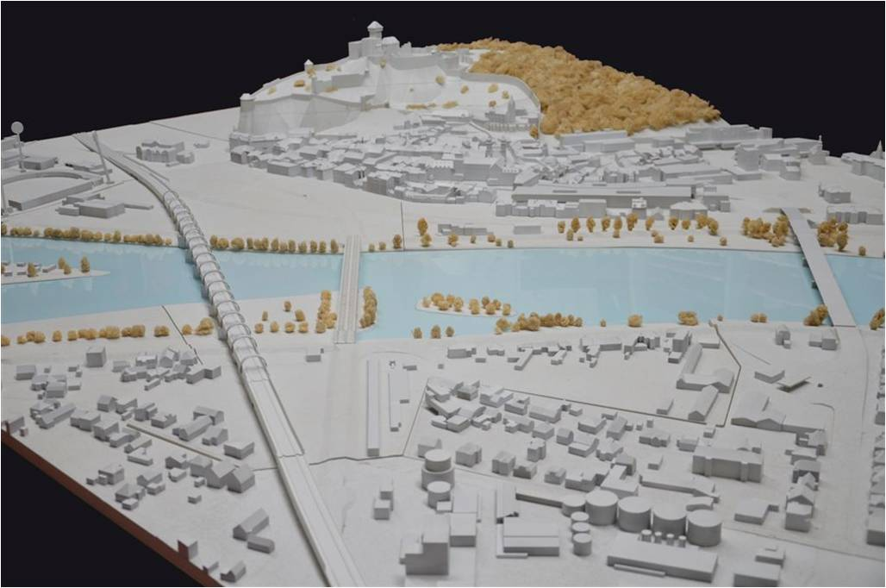
The model, into which individual proposals will be inserted as part of the competition evaluation process, will be on display in the cultural centre on Mirové Square in Trenčín throughout February 2014.

The leitmotif of the competition is to develop Trenčín into the most livable city in Slovakia and a city known around the world.
“I wish all teams who will take part in the competition fresh ideas and an open mind. I even wish the results will top the legacy of Ferdinand Silberstein-Silvan and his timeless urbanistic project of the Sihoť quarter in Trenčín” says the Mayor of Trenčín, Richard Rybníček, who endorsed the competition launch.

More info :
www.2014.trencin.sk
Jury end Experts :

The Jury

The jury has 11 members and 2 alternates. The jury operates through joint meetings, which may be as necessary facilitated through online electronic conference or per-rollam system, with the exception of meetings of the jury for the evaluation of the competition proposals, which can be carried out solely in personal attendance of all members of the jury. The jury is convened only if attended by all its members. In the absence of jury members, full attendance is secured at all times by one or more of the available jury alternates.

The jury will meet, discuss and decide as following:

Full members of the jury

Independent
Uli Hellweg (International Building Exhibition IBA Hamburg, Germany)
Prof.Robert Schnüll (Institut für Verkehrswirtschaft, Straßenwesen und Städtebau / Institute for Transport, Economics, Roadways and Town and City Planning, Hannover University; Associate of Schnüll, Haller und Partner – Hannover, Germany)
Prof.Thomas R. Matta (Profesor emeritus, HSR Hochschule für Technik Rapperswil / HSR College of Technology Rapperswil, Switzerland)
Drahan Petrovič (Institute of Urban Development (IUR), Vancouver-Canada / Bratislava-Slovakia)
Juraj Šujan (Slovenská komora architektov / Slovak Chamber of Architects, Bratislava)
Peter Gero (Development Director for the Central Districts of the city of Hamburg, a.D., Germany, Expert Guarantor of the project Trenčín in YOU, Trenčín, Slovakia)
Martina Veselá (Národní památkový ústav Telč / National Heritage Institute Telč, Czech Republic)
Daniela Gažová (SPECTRA Centre for EU Excellence by the Slovak Univeristy of Technology, Bratislava, Slovakia),
Pavol Kajánek (Director of Research and Development, Transport Research Institute, Žilina, Slovakia)
Tomáš Hanáček (PhD student, Faculty of Architecture STU Bratislava. Member of the project team „Trenčín is You“)
Representing the
competition organizer
Martin Beďatš (City of Trenčín, Chief Architect)
Alternate jury members in the following order:

1. Martin Baloga (ZUUPS – Združenie urbanistov a územných plánovačov Slovenska / Association of Urbanists and Urban Planners of Slovakia), independent
2. Eva Balašová (SB Partners, professional competence of urbanism and masterplanning, Bratislava, Slovakia), independent

Jury Experts
The jury experts will assess the technical completeness of received competition submissions. They will operate in form of a joint working meeting, during which they will assess all necessary technical requirements for all received submissions and drawn up a preliminary assessment of technical requirements for each submission. Both competition curator and competition secretary are present at the meeting of the jury experts. The competition secretary ensures the work of experts on technical and operational level, the competition curator is responsible for processing the contents of all the expert reviews and their subsequent issuing to the jury in Slovak and English.

Jury experts are working in a 10-member team from the following fields:

Heritage | Jozef Múdry (The Monuments Board of the Slovak Republic, Trenčín), independent
 | Lýdia Kubeková (The Monuments Board of the Slovak Republic, Bratislava, SR), independent
Ecology | Eva Wernerová (AWE – landscape design studio, Member of the Committee of Landscape Architects for the Slovak Chamber of Architects, Piešťany, Slovakia), independent
Waterways | Prof.Viliam Macura (Department of Water Management, Slovak University of Technology, Bratislava), independent
Urban economy | Viktor Nižňanský (Municipal Research and Advisory Centre, Piešťany, Slovakia), independent
Transport | Jiří Kašpar (Authorised transport engineer, HaskoningDHV, Prague, Czech Republic), independent
Transport | Jarmila Maslová (City of Trenčín – Department for Environment, Investment and Transport), representing the competition organizer
Urban safety | Vladimír Ondrejička (SPECTRA Centre for EU Excellence by the Slovak Univeristy of Technology, Bratislava, Slovakia), independent
Sociology, public opinion research | Miroslav Švec (Dicio Marketing, s.r.o. Bratislava, Slovakia), independent
Urbanism | Dušan Šimun (City of Trenčín – Department of the Chief Architect), representing the competition organizer

