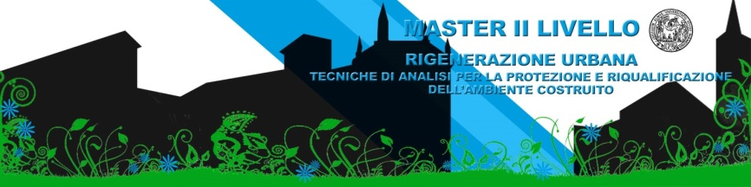
INTERNATIONAL CONFERENCE

“Sustainable Landscape and Responsible Tourism”
Parma 8th - 9th of March, 2018
Centro Congressi - Q02, Campus Universitario Parma
CALL FOR PAPERS
Dear colleagues,
The European Master in "Urban regeneration - Analysis techniques for the Protection and Re-qualification of the built environment" of the University of Parma, organizes the International Conference "Sustainable Landscape and Responsible Tourism" with the hope that this event becomes a high impact factor for the scientific community who deals with the topic of Urban Regeneration. International scientists will join the Campus Conference Centre of the University of Parma having the Urban Regeneration and the scientific language as a common interest.
The two days of the International Conference of Urban Regeneration will be articulated in the following thematic sessions:
Landscape’s regeneration and restoration;
Historical centres and minor cultural systems;
Requalification of coastal cities and waterfront;
Territorial regeneration or on large scale
Papers should be organized in three ways: oral presentation, oral presentation via streaming, poster presentation.
We invite you in a relatively short time, no later than February 26, 2018, to send an abstract, for one of the three presentation ways that will be evaluated by the Scientific Committee. The languages ​​of the conference will be Italian and English. The abstract in English or in Italian ​​must not exceed 300 words and must be written in word format.
To facilitate the uniformity of the abstracts, which will be published in a booklet with ISBN and distributed at the inauguration of the event, a template is enclosed in both official languages ​​of the Conference

Professor Paolo Ventura
European MSc in Urban Regeneration - Programme Director

Scientific Committee: Enrique Calderon, Eva Coisson, Damianos Damianakos, Aldo De Poli, Gianfranco Forlani, Paolo Giandebiaggi, Antonio Montepara, Maria Giovanna Tanda, Paolo Ventura, Michele Zazzi

Guidelines EN
Authors are required to submit an abstract. Manuscripts (oral or poster presentations) must be written in clear and grammatical English and should be submitted in electronic form at the conference secretary mastereurigenerazioneurbanpr@gmail.com no later than February 26, 2018
Title [Calibri 18]
Name and Surname [Calibri 12 Bold], title/position, affiliation, e-mail, [Calibri 12]
Keywords[Calibri 10.5 Bold]: Speakers are invited to mark up to 5 keywords, which they consider useful for categorizing their communication [Calibri 10,5]
Abstract [Calibri 10,5 Bold]
The abstract must be a summary of the presentation and must not exceed 300 words [Calibri 10,5]

